Integrative Approach for Computationally Inferring Protein Domain Interactions
See-Kiong Ng, Zhuo Zhang, Soon-Heng Tan
Bioinformatics 19(8), 923-929, 2003
Abstract
Given that protein-protein interactions involve physical interactions between protein domains, domain-domain interaction information can be useful for validating, annotating, and even predicting protein interactions. However, large-scale experimentally determined domain-domain interaction data do not exist; as such, we describe an integrative approach to computationally derive putative domain interactions from multiple data sources, including (1)rosetta stone sequences, (2)protein interactions, and (3)protein complexes.
- Introduction
Domains are modules of amino acid sequence within the proteins themselves with specific evolutionarily conserved motifs that have structural or functional implications. This paper attempts to address this problem by focusing on domain-domain interactions. As protein-protein interactions involve physical interactions between the proteins’ subunits or domains, domain-domain interactions can be useful for validating, annotating, and even predicting protein interactions.

- Method
(1)Score from protein interactions
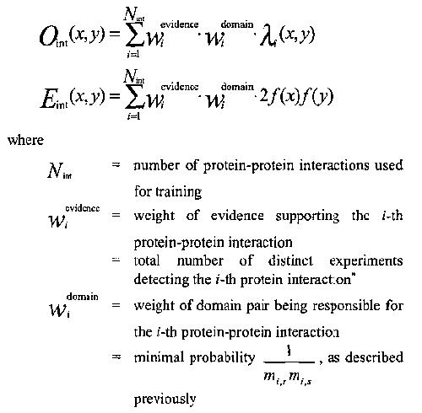

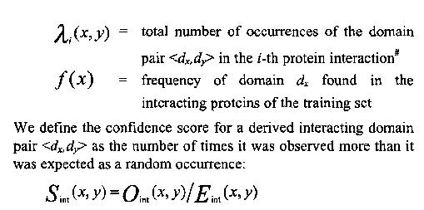

(2)Score from protein complex
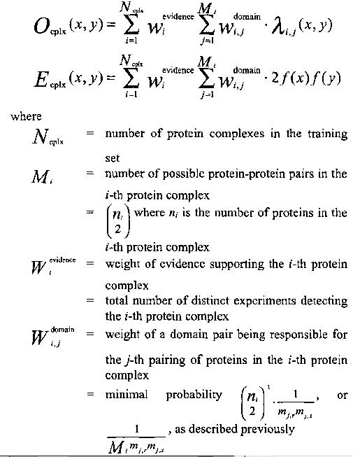

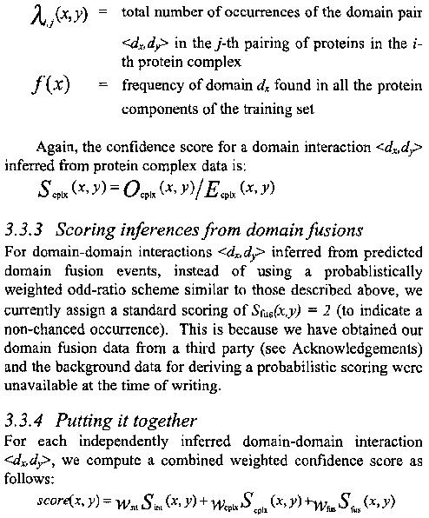

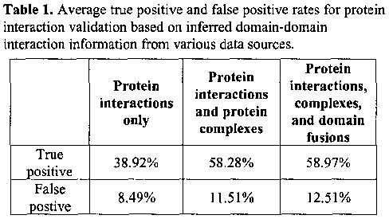

Created by : Yung-Hsing Peng
Date : Dec. 26, 2003

